C-SW311 Software Design and Development

Fall 2025

Project: Customer Relationship Management (CRM) System for Breadfast

Done by:
Mira Michael 23-101038
Zeina Shalaan 23-101012
Maya Shalash 23-101004
Menna-Tallah Amr 23-101022

System Vision Document
Breadfast CRM System
Problem Description
Breadfast, a fast-growing food delivery company, is facing challenges in managing its daily operations due to scattered data and disconnected departments. Customer information and order history are spread across multiple systems, making it difficult for support agents to provide quick and consistent service. The absence of a shared, real-time view of orders causes miscommunication between teams, resulting in delays and errors. Delivery operations are also inefficient, as rider assignments are done manually with limited visibility, leading to uneven workloads and late deliveries. In addition, managers struggle to make data-driven decisions because of the lack of integrated reports and analytics. Staff members spend excessive time on repetitive manual tasks, such as updating records individually, which reduces productivity and slows down the overall process. These issues collectively hinder Breadfast’s ability to operate smoothly, maintain customer satisfaction, and scale effectively as the company continues to grow.
System Capabilities
The CRM will provide:
- Unified Customer Profile: Centralized data combining personal info, orders, payments, and communication history.
- Smart Segmentation: Automatic grouping of customers by value, behavior, or location for targeted campaigns.
- Central Order Dashboard: Real-time order tracking and status updates shared across departments.
- Sales & Analytics Dashboard: Insights on top products, delivery performance, and customer trends.
- Inventory & Supplier Management: Basic ERP features for tracking stock, setting low-stock alerts, and managing suppliers.
- Integrated Communication Hub: Combines all customer interactions — chat, email, and calls — into a single interface, ensuring consistent and timely communication across departments.
Business Benefits
The system will bring clear improvements to operations and customer experience:
- Enhanced Customer Service: A unified system enables faster, more personalized support and strengthens customer loyalty through better tracking and engagement.
- Improved Operational Efficiency: Centralized data and automated workflows reduce manual effort, minimize human error, and streamline coordination across teams.
- Optimized Delivery Performance: Smart dispatching tools ensure balanced workloads, minimize delays, and reduce operational costs such as fuel and idle time.
- Informed Decision Making: Real-time analytics dashboards provide insights into sales trends, customer behavior, and product performance to support strategic planning.
- Scalable Growth: The integrated platform offers a stable foundation that supports increasing order volumes and future expansion.
- Secure System Access: Role-based permissions protect sensitive data and maintain clear operational control across departments.

Stakeholders:

Stakeholder Group | Internal / External | Operational / Executive | Description
Customer Support Agents | Internal | Operational | Use the CRM's unified customer profile to provide fast, accurate, and personalized support. Their efficiency is tied to having complete customer data on a single screen
Sales Team | Internal | Operational | Utilize the Sales and Analytics Dashboard to understand customer trends and product performance to inform strategies and targets.
Delivery Dispatchers | Internal | Operational | Work within the Delivery and Logistics Hub to monitor rider GPS tracks, assign orders based on proximity/availability, and manage delivery zone capacities
Inventory Managers | Internal | Operational | Rely on the Inventory and Supplier Management module to track stock levels, receive low-stock alerts, manage supplier information, and analyze waste reports.
Riders | Internal | Operational | The end-users of the delivery coordination aspect. Their performance metrics (punctuality, orders/hour) are tracked by the system, directly impacting their workflow and evaluation.
Purchasing Office | Internal | Operational | Contacts suppliers, negotiates prices, and manages purchase orders.  Works directly with suppliers and finance department.
System Administrators | Internal | Operational | Manage the system's backend, configure Role-Based Access Control (RBAC), and perform Bulk Actions to maintain system efficiency and data integrity.
Senior Management | Internal | Executive | Use the high-level analytics and real-time dashboards for data-driven decision-making, strategic planning, and monitoring overall business health (e.g., delivery delays, cancellation rates).
Regulators | External | Executive | Interact with the system's compliance and reporting features to ensure adherence to food safety, data privacy, and labor regulations. They may audit data logs, review safety reports, and monitor operational metrics to ensure legal and regulatory compliance.

Functional Requirements

1. Customer Management:
- Create customer profile (personal details, order history, and complaints history)
- Retrieve customer information.
- Edit and update customer information.
- Search and filter customers (by name, email, phone number, or location).
- Segment customers based on factors (purchase frequency, order value, or region).
2. Order Management:
- Update order status (“Processing,” “Dispatched,” “Delivered,” “Cancelled”).
- Filter and sort orders (delivery zone, order date, or rider assignment).
- Retrieve order status.
- View and access full order history for any customer.
- Track current orders and update delivery status in real time.

3. Delivery & Dispatch Management:
- Generate alerts for delayed or failed deliveries.
- Log rider performance data (completed deliveries, delivery times, and feedback).
- Provide weekly delivery performance reports for review.

4. Communication & Support Hub
- Chat or message other users
- Allow support agents to respond to messages directly from the CRM.
- Notify agents of new messages, complaints, or unresolved issues.
- Track resolution times and agent performance.
- Notify customers of order progress and delivery confirmation.

5. Inventory & Supplier Management:
- Track stock for each product in real time
- Record stock status for each product
- Generate low-stock alerts “when inventory falls below the threshold”
- Add supplier details (contact Information, related products)
- Edit/archive supplier details
- Record purchase orders and restocking history
- Track historical sales and demand patterns

6. Sales & Analytics Dashboard:
- Display sales performance metrics (Total sales, top-selling products, and revenue trend).
- Show delivery metrics (average delivery time and success rate).
- Create charts and summaries for management review (filtering by time period, product category, or location).
- Display daily or weekly delivery performance reports.

Requirements Elicitation Techniques:
Primary Elicitation Techniques
These techniques are directly suited to uncover the core functional and data needs of the Breadfast CRM.

Technique | Description | Why It's Selected for Breadfast CRM | Outcome
Stakeholder Interviews | Structured or semi-structured one-on-one conversations with key individuals from each stakeholder group. | To gain deep, detailed insights from specific roles (e.g., Delivery Dispatcher, Inventory Manager, Customer Agent) about their pain points, daily workflows, and specific needs. This is ideal for uncovering nuanced requirements. | Transcripts, Follow up notes , list of needs , initial User Stories
Questionnaires with all Riders and Customers | Distribute structured surveys to a large group to quantify preferences, identify common issues, and validate findings from other techniques. | Helps prioritize features based on user problems , frequency and impact | To get data on user needs and problems.
Reviewing Input & Output | Analyze existing documents, forms, and system data. | Gets Clear understanding of the information flow and its flaws | A comprehensive list of data entities, attributes, and business rules.
Research | Study industry standards for CRM/ERP systems | Helps get inspiration of standard features across other CRM/ERP systems | A list of technical constraints and inspiration for standard features

Interview Agendas and Questionnaire

Breadfast CRM Internal User Questionnaire
This questionnaire is being sent to all internal operational staff. As you know, Breadfast is developing a new integrated CRM system to streamline our operations and improve customer service.
The purpose of this questionnaire is to obtain preliminary information to assist in defining the requirements for the new system. Follow-up discussions will be held to permit everybody to elaborate on their needs and ideas.

Part I. Please answer these questions based on a typical workday
- On average, how many customer inquiries (calls, chats, emails) do you handle per day? _______________
- How many different systems or screens do you need to open to resolve a single customer issue? ______
- How many times per day do you have to contact another department (e.g., call Delivery, email Warehouse) to get information for a customer? ___________________________________
- Estimate the percentage of your shift spent on manual data entry or updating records in multiple places. ______%
- How many times per day do you encounter issues due to outdated or incorrect order status information? _________________________________________
- For delivery teams: How many orders are typically reassigned manually per shift due to inefficiencies? ________

Part II. Circle the appropriate number on the scale from 1 to 7 based on how strongly you agree or disagree with the statement.
Question | Strongly Agree Strongly Disagree
It would help me do my job better to have a single, unified view of all customer information (profile, order history, communications). | 1 | 2 | 3 | 4 | 5 | 6 | 7
A real-time dashboard showing order status from kitchen to delivery would significantly reduce customer complaints. | 1 | 2 | 3 | 4 | 5 | 6 | 7
Having all customer communication (email, chat, call) in one place would make me more efficient. | 1 | 2 | 3 | 4 | 5 | 6 | 7
Automated low-stock alerts would help prevent issues with customer orders. | 1 | 2 | 3 | 4 | 5 | 6 | 7
A system that automatically assigns delivery riders based on location and workload would improve delivery times. | 1 | 2 | 3 | 4 | 5 | 6 | 7
The current process for finding basic customer or order information is slow and frustrates both me and the customer. | 1 | 2 | 3 | 4 | 5 | 6 | 7

Part III. Open-Ended Comments & Suggestions
Please briefly identify the biggest problems with the current systems and describe one feature you would most like to see in the new CRM.
________________________________________________________________________________________
(Please use the space below for your comments)

Internal Executive Interview — Breadfast CRM System
Role Interviewed: Operations Manager (Internal Executive).

How satisfied are you with the current process of managing orders
How do you currently manage and oversee the end-to-end process of order handling and delivery operations?
(Please describe your workflow from order placement to successful delivery.)
- What specific information or inputs do you and your team need to start your daily operations, and what outputs or reports do you generate?
- How satisfied are you with the current process of managing orders and deliveries?
☐ Very satisfied ☐ Somewhat satisfied ☐ Neutral ☐ Dissatisfied ☐ Very dissatisfied
- What are the most common challenges you and your team face during the daily delivery and coordination process?
- What manual or repetitive tasks take up most of your team’s time and should be automated in the new CRM system?
- What specific CRM features do you believe would most improve coordination between Customer Support, Delivery, and Operations?
- Should all departments have full access to customer and order data, or should access be role-based?
☐ Full access for all ☐ Role-based access only ☐ Not sure
Why?
- What types of dashboards or reports would help you make faster, data-driven operational decisions?
- In your view, what would define a successful CRM system implementation six months after launch?

Workflow Documentation:
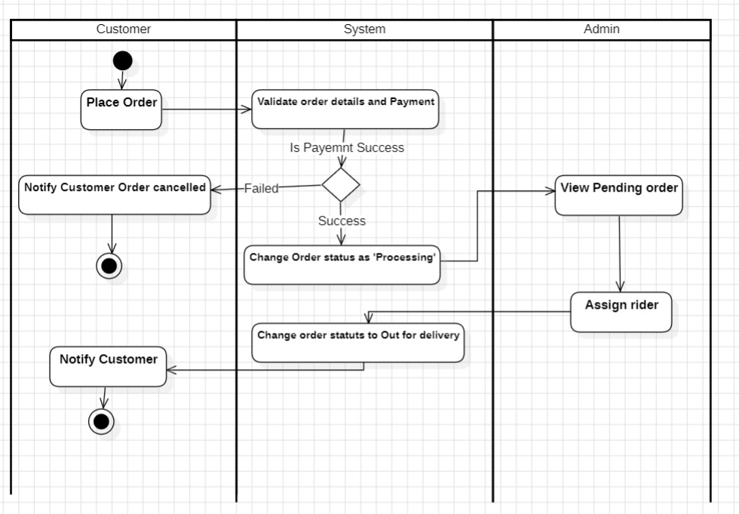
Order process
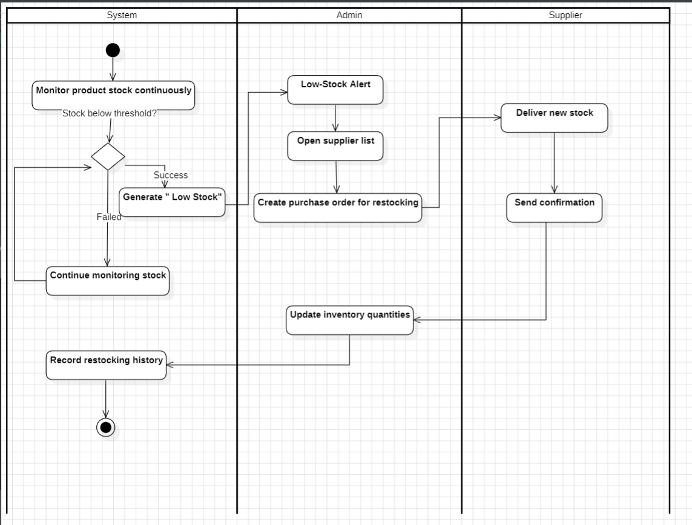
Track Inventory and Restock

Jira Summary:
Our team used Jira to stay organized and keep track of progress throughout the project. Each task was clearly defined with descriptions and deadlines, then moved step by step from “To Do” to “In Progress,” “In Review,” and finally “Done.” This helped everyone stay on the same page, see what had been completed, and understand what still needed attention. Jira made it easy for the whole team to collaborate smoothly and stay aligned with the project timeline.

GitHub Link:
https://github.com/MiraMichael-coder/CRM.git

